Website Analysis
https://example.com/
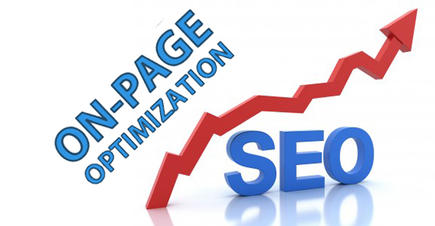

Basic SEO Friendly Factors Analysis: On-Page

Title Tags | Present (Need to Optimize)
Meta Description | Present (Need to Optimize)
Meta Keywords | Missing
H1,H2 Tags / Headings | Missing
Robots.txt | Present
XML Sitemap | Present
Image Alt Tag | Missing
Google Webmaster Code | Missing in Source Code
Google Analytics Code | Present
HTTPS Test | Great, using secure server(HTTPS)
Speed Test (gtmetrix.com) | Speed Score - F (0%)
Dead links (brokenlinkcheck.com) | Resolved
301 Redirection | Resolved
Text to HTML Ratio | 6.65%
404 Error | Not Present
Mobile Friendly Test | Website is Mobile Friendly
URL Structure | All URLs are SEO Friendly
Duplicate Content Issue | Not Found
Underscores in the URLs | Great, you are not using underscores in URLs
Favicon | Present
Blog on Website | Present
Social Media Presence | Present
Google & Bing Places | Not Verified

Meta Title

Meta Title is present on your website, but there is a need to optimize website them according to the keywords. Ideally, your title should contain between 65 to 70 characters including spaces.

0 pages don't have Meta Title

Your title provides users and search engines with useful information about your site. Text contained in title tags can appear in search results pages, and relevant, descriptive text is more likely to be clicked on. Title tag can be better optimized using the keywords for home page and all internal pages.

0 issues with duplicate Meta Title

With duplicate Meta Title, you end up with pages that appear the same to users browsing search results. Having two pages compete for the same terms is confusing to Google and will only harm your rankings. It’s also confusing to users who may skip over a page that may have solved their problem and benefited you.

0 pages have too much text within the Meta Title (over 65 characters)

If your title is too long, search engines may cut it off—adding an ellipsis ("...")—and could end up not displaying important words. Google typically displays the first 50-60 characters of a title tag.

0 pages have less text within the Meta Title (below 30 characters)

If you title is very short, you may be missing an opportunity to get descriptive in your meta titles. It is important to use high-quality titles on your web pages but title must be descriptive. Titles below 30 characters or 50 characters, it doesn't matter. But for better optimization we can use important keywords in the Title.

Meta Description

Similar to the title tag, the Meta description tag gives you the ability to show potential visitors what your page is about before they click. Think of the Meta description as ad space. In 150-160 characters or less you need to convince someone that your page is more valuable than the other results nearby.

0 Pages don't have Meta Descriptions

While analyzing your website, Meta descriptions are not present on your website. And also Meta keywords are missing on the website. Meta tags include web page’s description, keywords and various other important factors which play very important role in search engine ranking. We can use keywords in description for better performance in search engines.

0 issues with duplicate Meta Descriptions

With duplicate Meta Descriptions, you end up with pages that appear the same to users browsing search results. Having two pages compete for the same terms is confusing to Google and will only harm your rankings. It’s also confusing to users who may skip over a page that may have solved their problem and benefited you.

0 Pages have too much text within the Meta Descriptions (over 156 characters)

Meta descriptions can be any length, but search engines generally truncate snippets longer than 156-160 characters—adding an ellipsis ("...")—and could end up not displaying important words.

0 Pages have less text within the Meta Description (below 30 characters)

The character length for the first line of the description has been extended to 100 characters. If your Meta description is under 100 characters, then it will be reduced to only one line of text. Basically, this means that the search result for that page will take up less space, and be less visible to searchers, ultimately lowering your click-through rate.

For the pages with Meta descriptions fewer than 100 characters, lengthening them should be a priority.

0 pages missing the H1 tag

Heading tags are missing your website. The H1, H2 tags are the most important heading tag because it’s the highest level of the heading tags hierarchy which indicates what your specific page is about. Search engines generally give this tag more weightage over other headings.

0 pages have multiple H1 tag (more than one)

Search engine looks at h1 tags as clues to what the page's content is about. If you have multiple h1 tags with different keywords then it is difficult for Google to contextualize the page. The presence of more than one h1 won’t necessarily confuse the search engine, but it could dilute the SEO power of a single h1. Each page should have only one, <H1> tag.

0 Images missing the alt text

“Alt text” is a snippet of text that is used to define the images you are using on your website. Search engines can’t understand images, but they do understand text. And “alt text” for an image helps the search engines understand what the image is all about. It should be relevant, short, catchy, and concise.

Google Analytics

Google analytics script is not present in your website source. Use of Google analytic will be helpful in tracking visitors and traffic sources on various keywords. The Google Analytics code is to be placed in the header section. This code is important to be placed at the right place as it provides a proper analysis of the website and we can check our progress and change the optimizing strategy (if required) using this tool.

Google Webmaster Code

Google Webmaster Tools Code is not installed on the website’s source code. Google Webmaster Tools provides you with detailed reports about your website’s visibility on Google. It also tells you about the main keywords which are getting ranked in Google. To get started, simply add and verify your site and you'll start to see information right away with in 24-48 hours.

XML Sitemap

Website lacks Sitemap.xml file. Sitemap.xml is very useful file in SEO. Through this file Search Engine’s crawler get information about how many web pages exist in the website. A link to the dynamic Sitemap should be added.

Robots.txt

Website lacks robots.txt file. Robots.txt is very useful file in SEO. Through this file Search Engine’s crawler get information about which web pages of website are under construction or which web pages should not count for crawling. As per the information of robots.txt, search engine crawlers will not count mentioned web pages in it for indexing and ranking for SERP.

Text to HTML Ratio

The Text to HTML ratio on your website is 6.65%, which is not good. Low Text to HTML ratio indicates little content for search engines to index. We consider it to be good practice to have a Text to HTML ratio of at least 10% and ideal above 20%.

Permanent Redirect 301

Need to resolve the http://www.idtronic-rfid.com/ & http://idtronic-rfid.com/ URL. Search Engines consider http://www.idtronic-rfid.com/ & http://idtronic-rfid.com/ as two different URL's. According to Search Engines these are two different websites and link juice is divided. So it should be one URL, I suggest “http://www.idtronic-rfid.com/”.

404 Errors

We need to correct the 404 error as if anyone types a wrong URL, the user must stay on the website instead of navigating to some other page. This can be done by redirection to the home page, site map page or a special page can be created so as to define the user that the URL he typed dose not exists and check the URL again.

GTmetrix Website Speed Score

Website loading speed score is F that is not good. Having a slow loading website can be frustrating, and can lead to less traffic visiting your site. So, we are suggesting you to look at some important factors to improve website speed.

0 Pages have issue with broken links

A broken link is a link that doesn't work, often resulting in an error page. A broken link happens when the link points to a web page that has been deleted or moved. Why is it important to fix a broken link? Links that are broken will effectively stop search engines from completely indexing your website.

Mobile Friendly Test

While analyzing your website I found your website is not a Mobile Friendly. A mobile-friendly website is one that displays correctly on hand-held devices such as smartphones, iPhones, iPads, and tablets. Google may also penalize you if you don’t have a mobile friendly website. So, it’s very important to change your standard website to a Responsive website ASAP.

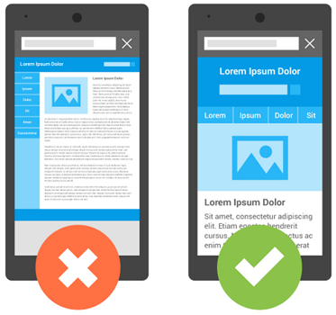

Content

Rich and unique text based content is a major aspect of website optimization. It is an important element that search engines look at while ranking a web page. You may have heard of the expression “Content Is King”. If your competitors have more quality and unique content than you then it is highly unlikely you will be able to surpass them.

The search engines rate a website higher if there is good content containing a good percentage of important keywords. Similarly, it's important to write keyword-rich content that focuses on the 'theme' for that particular page, while avoiding spamming the search engines with extraneous keywords. Page text should be written in a 'natural' way that reads well to the user and must not be duplicated from other websites.

Search engines reward websites that updates their content often by moving them up in rankings. By doing this we give our visitors a reason to come back which will increase the chance of closing a transaction.

10 Pages have issue with underscore in the URL’s

While analyzing your website I found underscore in the page URLs. SEO URLs should use hyphens to separate words. Do not use underscores. Google treats a hyphen as a word separator, but does not treat an underscore that way. Google treats and underscore as a word joiner — so red_sneakers is the same as redsneakers to Google.

Blog section is not present on the website

Blog section is not found on the website. Blogging is good for SEO because it helps with a number of things that are important ranking factors. When you have a blog that's updated regularly with blog posts that are high quality and on topics relevant to your audience.

Favicon

Favicon is not present on the website. This icon indicate the site identification and branding. It’s normal sizes is 16×16 pixels or 32x32 pixels that usually contain the logo, the first letter of the brand or a generic image that represents the business type.

Not Listed on Google & Bing Places

While searching for your business on Google and Bing Listed is not present. By creating a Google My Business listing, your business information can show up in Maps, Search, and other Google properties.

Identity

Company Logo | Present
Company Contact Page | Present

Social Links

Facebook Button/widget | Present (Need to add Profile Links)
Twitter Button | Present (Need to add Profile Links)
Pinterest Button | Missing
Instagram Button | Present (Need to add Profile Links)
YouTube Button | Missing
Linkedin Button | Missing

Facebook, Twitter and Instagram social media channels are present but need to update thehippiemommashop profile links. There are also need to add more social media channels like Pinterest, YouTube and LinkedIn. These social networks generally used for generating traffics for website.

CONCLUSION

The whole idea is to get insight of the website in terms of On Page. I will optimize your website (On Page issues) to achieve better performance for our SEO campaign and enhance the visibility in Google SERP.

